|  |  |
| --- | --- |
| COURSE MATERIAL | |
| SUBJECT | **ELECTRICAL MEASUREMENTS (15A02501)** |
| UNIT | **3** |
| COURSE | **B.TECH** |
| DEPARTMENT | **ELECTRICAL & ELECTRONICS ENGINEERING** |
| SEMESTER | **31** |
| PREPARED BY  (Faculty Name/s) | **Dr. Y.HARI KRISHNA**  **Associate Professor** |
| Version | **V-1** |
| PREPARED / REVISED DATE | **21-12-2020** |

|  |  |  |  |
| --- | --- | --- | --- |
| TABLE OF CONTENTS – UNIT 1 | | | |
| S. NO | **CONTENTS** | | **PAGE NO.** |
| 1 | **COURSE OBJECTIVES** | | **1** |
| 2 | **PREREQUISITES** | | **1** |
| 3 | **SYLLABUS** | | **1** |
| 4 | **COURSE OUTCOMES** | | **1** |
| 5 | **CO - PO/PSO MAPPING** | | **2** |
| 6 | **LESSON PLAN** | | **2** |
| 7 | **ACTIVITY BASED LEARNING** | | **2** |
| 8 | **LECTURE NOTES** | | **2** |
|  | **3.1** | **ELECTRODYNAMOMETER WATTMETER** | **2** |
|  | **3.2** | **LOW POWER FACTOR WATTMETER** | **7** |
|  | **3.3** | **THREE PHASE POWER MEASUREMENT** | **9** |
|  | **3.4** | **POWER FACTOR METER** | **12** |
|  | **3.5** | **SINGLE PHASE ELECTRODYNAMOMETER POWER FACTOR METER** | **12** |
|  | **3.6** | **THREE PHASE ELECTRODYNOMETER POWER FACTOR METER** | **14** |
|  | **3.7** | **MOVING IRON POWER FACTOR METER** | **16** |
|  | **3.8** | **ENERGY METER** | **18** |
| 9 | **PRACTICE QUIZ** | | **25** |
| 10 | **ASSIGNMENTS** | | **46** |
| 11 | **PART A QUESTIONS & ANSWERS (2 MARKS QUESTIONS)** | | **46** |
| 12 | **PART B QUESTIONS** | | **48** |
| 13 | **SUPPORTIVE ONLINE CERTIFICATION COURSES** | | **48** |
| 14 | **REAL TIME APPLICATIONS** | | **48** |
| 15 | **CONTENTS BEYOND THE SYLLABUS** | | **49** |
| 16 | **PRESCRIBED TEXT BOOKS & REFERENCE BOOKS** | | **49** |
| 17 | **MINI PROJECT SUGGESTION** | | **49** |

1. **Course Objectives**

The objectives of the course are to make the student learn about

1. The basic principles of different types of electrical instruments for the
2. Measurement of voltage, current, power factor, power and energy.
3. The measurement of R, L, and C parameters using bridge circuits.
4. The principles of magnetic measurements.
5. The principle of working of CRO and its applications.
6. The use of Current Transformers, Potential Transformers, and Potentiometers.
7. **Prerequisites**

Students should have knowledge on

1. Basic Electric circuits
2. Basic Mathematics
3. **Syllabus**

**UNIT 3**

**MEASUREMENT OF POWER AND ENERGY**

Single Phase Dynamometer Wattmeter, LPF and UPF, Double Element and Three Element Dynamometer Wattmeter, Expression for Deflecting and Control Torques. Types of P.F. Meters – Dynamometer and Moving Iron Type – 1-ph and 3-ph Meters. Single Phase Induction Type Energy Meter – Driving and Braking Torques – Errors and Compensations. Three Phase Energy Meter

.

1. **Course outcomes**
2. Use watt meters, pf meters, and energy meters in a given circuit.
3. Extend the range of ammeters and voltmeters
4. Measure active power, reactive power, power factor, and energy in both 1-phase and 3-phase circuits
5. Determine the resistance values of various ranges, L and C values using appropriate bridges.
6. **Co-PO / PSO Mapping**

|  |  |  |  |  |  |  |  |  |  |  |  |  |  |  |
| --- | --- | --- | --- | --- | --- | --- | --- | --- | --- | --- | --- | --- | --- | --- |
| Machine Tools | PO1 | PO2 | PO3 | PO4 | PO5 | PO6 | PO7 | PO8 | PO9 | P10 | PO11 | PO12 | PSO1 | PSO2 |
| CO1 | 3 | 3 |  |  |  |  |  |  |  |  |  |  | 2 | 2 |
| CO2 | 3 | 3 |  |  |  |  |  |  |  |  |  |  | 2 | 2 |
| CO3 | 3 | 3 |  |  |  |  |  |  |  |  |  |  | 2 | 2 |
| CO4 | 3 | 3 |  |  |  |  |  |  |  |  |  |  | 2 | 2 |

1. **Lesson Plan**

|  |  |  |  |
| --- | --- | --- | --- |
| Lecture No. | Weeks | Topics to be covered | References |
| 1 | **1** | Electrodynamometer wattmeter | T1 |
| 2 | Low power factor wattmeter | T1, R1 |
| 3 | Three phase power measurement | T1, R1 |
| 4 | Power factor meter | T1, R1 |
| 5 | **2** | Single phase electrodynamometer power factor meter | T1, R2 |
| 6 | Three phase electrodynometer power factor meter | T1, R1 |
| 7 | Moving iron power factor meter | T1, R1 |
| 8 | Energy meter | T1, R1 |
| 9 | **3** | Discussion of objective type questions &Short answer questions | T1, R1 |
| 10 | Discussion of Previous year university questions in question papers | T1, R1 |

1. **Activity Based Learning**
2. Measurement of power ,calibration of energy meter
3. Measurement of power and pf , calibration of wattmeter
4. **Lecture Notes**

**3.1** **Electrodynamometer Wattmeter**

The instrument whose working depends on the reaction between the magnetic field of moving and fixed coils is known as the Electro dynamo-meter Wattmeter. It uses for measuring the power of both the AC and DC circuit

**3.1.1**  **The working principle of the Electrodynamometer Wattmeter**

The working principle of the Electrodynamometer Wattmeter is very simple and easy. Their working depends on the theory that the current carrying conductor placed in a magnetic field experiences a mechanical force. This mechanical force deflects the pointer which is mounted on the calibrated scale.

**3.1.2 Construction of Electrodynamometer Wattmeter**

The following are the important parts of the Electrodynamometer Wattmeter.

* Moving Coil
* Fixed coil
* Control
* Damping
* Scales and pointers

**Fixed coil**

The fixed coil connects in series with the load. It is considered as a current coil because the load current flows through it. the fixed coil divide into two parts. The fixed coil produces the uniform electric field which is essentials for the working of the instruments. The current coil of the instruments is designed to carry the current of approximately 20 amperes for saving the power**.**

**Moving Coil**

The moving coil consider as the pressure coil of the instruments. It connects in parallel with the supply voltage. The current flows through them are directly proportional to the supply voltage. The pointer mounts on the moving coil. The movement of the pointer controls with the help of the spring.

**Control system**

The control system provides the controlling torque to the instruments. The gravity control and the spring control are the two types of control system. Out of two, the Electrodynamometer Wattmeter uses spring control system. The spring control system is used for the movement of the pointer.

**Damping**

The damping is the effect which reduces the movement of the pointer. In this Wattmeter the damping torque produces because of the air friction. The other types of damping are not used in the system because they destroy the useful magnetic flux.

**Scales and pointers**

The instruments use a linear scale because their moving coil moves linearly. The apparatus uses the knife edge pointer for removing the parallax error which causes because of oversights.

**3.1.3 Working of Electrodynamometer Wattmeter**

The Electrodynamometer Wattmeter has two types of coils fixed and the moving coil. The fixed coil connects in series with the circuit whose power consumptionuse to be measured. The supply voltage applies to the moving coil. The resistor controls the current across the moving coil, and it is connected in series with it.

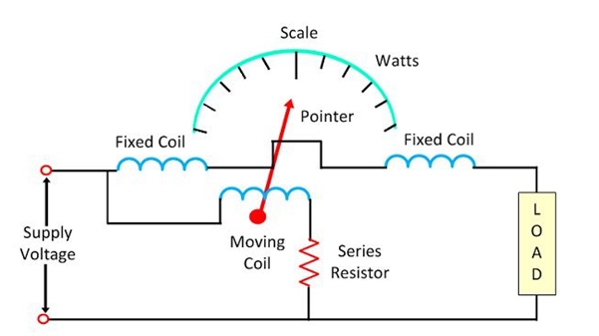

Fig. 3.1 Electrodynamometer Wattmeter

The pointer is fixed on the moving coil which is placed between the fixed coils. The current and voltage of the fixed and moving coil generate the two magnetic fields. And the interaction of these two magnetic fields deflects the pointer of the instrument. The deflection of the pointer is directly proportional to the power flows through it.

**3.1.3 Theory of Electrodynamometer Wattmeter**

The circuit diagram of the electrodynamo meter wattmeter is shown in the figure The instantaneous torque acts on the pointer of the wattmeter and is given by the equation

wattmeter-equation-1

Where,  ip – pressure coil current  
 ic– current coil current  
 dm/dθ – the rate of change of deflection of pointer

concerning angle θ

The voltage across the pressure coil of the circuit is given as

wattmeter-equation-2

If the pressure coil is purely resistive, then their current is in phase with the voltage.  And the value of current is given by the equation

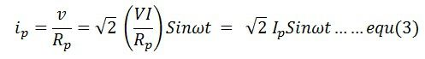

If the current coil lag by a voltage in phase angle Φ, the current through the current coil is given as ip = √2Isin(ωt-∅)

The value of the current in the pressure coil is very small. Hence the current flows through the pressure coil are considered as the total load current. The torque acts on the coils becomes  The average deflection torque is obtained by integrating the torque from 0 to T limit. The average deflection torque of the coil is given as The controlling torque exerted on the spring is given by

wattmeter-equation-4

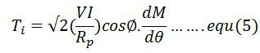

wattmeter-equation-6

**3.1.3 Errors in Electrodynamometer Wattmeter**

**The following are the errors in the Electrodynamometer Wattmeter**

**Pressure Coil Inductance** – The pressure coil of the Electrodynamometer has some inductance. Because of the inductance, the current of the pressure coils lags behind the voltage. Thus, the power factor of the wattmeter becomes lagging, and the meter reads high reading.

**Pressure Coil Capacitance** – The pressure coil has capacitances along with the inductance. This capacitance increases the power factor of the instrument. Hence causes the error in the reading.

**Error due to Mutual Inductance Effect** – The mutual inductance between the pressure and current coil produces an error.

**Eddy Current Error** – The eddy current induces in the coil creates its own magnetic field. This field affects the main current flows through the coil. Thus, the error occurs in the reading.

**Stray Magnetic Field**  – The stray magnetic field disturbs the main magnetic field of the Electrodynamic Wattmeter. Thus, affect their reading.

**Temperature Error** – The variation in temperature will change the resistance of the pressure coil. The movement of the spring, which provides the controlling torque also affected because of the temperature change. Thereby, the error occurs in the reading.

**3.2 LOW POWER FACTOR WATTMETER**

**3.2.1 What is the need of LPFW?**

The ordinary Wattmeter used for measuring the low power factor gives the inaccurate result. This happens because of two reasons.In low power factor meter, the magnitude of deflecting torque on moving coil is small even after the full excitation of the pressure and current coil. The error occurs in the reading because of the pressure coil inductance. Some additional features are added on the ordinary Wattmeter so that the meter can measure the power of the low power factor circuit**.**

**3.2.2 Modifications in Ordinary Wattmeter**

**Compensation For Inductance of Pressure Coil** **(Method 1)**

The small amount of inductances is present in the pressure coil of the Wattmeter. This inductance causes the error in the reading. The error occurs in the pressure coil is given by the expression

VI Sinφ tanβ

The φ is the angle between the pressure and the current coil. For a small value power factor φ is large. The large value of φ causes a large error in the reading. The compensating coil is used in the circuit for compensating the inductance error occurs in the Wattmeter. Along with the compensating coil, the capacitor is used in the circuit. The capacitor is placed in parallel with the pressure coil resistance.

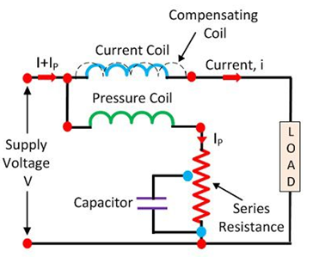

Fig. 3.2 Compensation For Inductance of Pressure Coil

**Compensation for Pressure Coil(Method 2)**

 the pressure coil is not connected in parallel with the load. Thereby, the magnitude of the pressure coil voltage is not equal to the supplied voltage. The output power obtains from the circuit is equal to the sum of the load power loss and the power loss of the pressure coil.

In low power circuit, the value of current is high, and that of the power is low. The high-value current causes the error in the Wattmeter reading. For reducing the error, the compensation coil is used in the circuit. The compensating coil compensates the error in the circuit which induces because of low power factor.

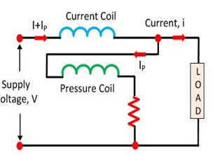

Fig. 3.3 Compensation for Pressure Coil(Method 2)

**3.3 THREE PHASE POWER MEASUREMENT**

The pressure coil of all the Three wattmeter namely W1 , W2 and W3 are connected to a common terminal known as the neutral point. The product of the phase current and line voltage represents as phase power and is recorded by individual wattmeter

**The connections for Star connected loads for measuring power by Three wattmeter method**

The pressure coil of all the Three wattmeter namely W1 , W2 and W3 are connected to a common terminal known as the neutral point. The product of the phase current and line voltage represents as phase power and is recorded by individual wattmeter**.**

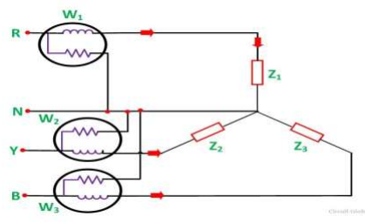

Fig. 3.4 The connections for Star connected loads for measuring power

**The connections for Delta connected loads for measuring power by Three wattmeter method**

Single phase wattmeters are connected in each phase of load as shown

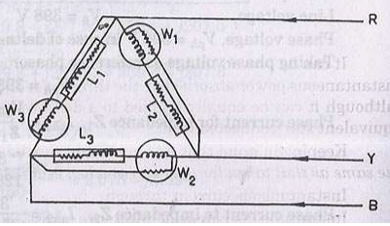

Fig. 3.5The connections for Delta connected loads for measuring power

The total power in a Three wattmeter method of power measurement is given by the algebraic sum of the readings of Three wattmeter. i.e.

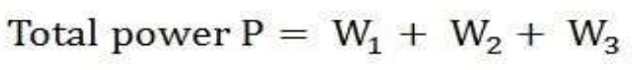

W1 = V1 I1

W2 = V2 I2

W3 = V3 I3

**3.3 A DYNAMOMETER TYPE THREE-PHASE WATTMETER**

A dynamometer type three-phase wattmeter consists of two separate wattmeter movements mounted together in one case with the two moving coils mounted on the same spindle. There are two current coils and two pressure coils.A current coil together with its pressure coil is known as an element. Therefore, a three phase wattmeter has two elements. The connections of two elements of a 3 phase wattmeter are the same as that for two wattmeter method using two single phase wattmeter. The torque on each element is proportional to the power being measured by it.

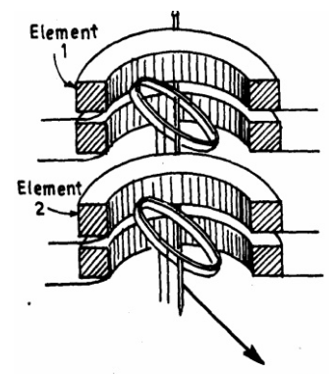

Fig. 3.6dynamometer type three-phase wattmeter

• The total torque deflecting the moving system is the sum of the deflecting torque of’ the two elements. • Hence the total deflecting torque on the moving system is proportional to the total Power. • In order that a 3 phase wattmeter read correctly, there should not be any mutual interference between the two elements. • A laminated iron shield may be placed between the two elements to eliminate the mutual effects

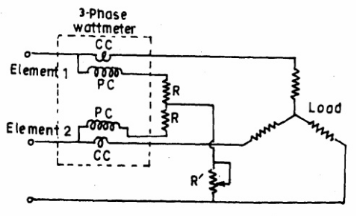

Fig. 3.7 two wattmeter method of power measurement

**3.4 POWER FACTOR METER**

The power factor meter measures the power factor of a transmission system. The power factor is the cosine of the angle between the voltage and current. The power factor of the transmission line is measured by dividing the product of voltage and current with the power. And the value of voltage current and power is easily determined by the voltmeter, ammeter and wattmeter respectively. This method gives high accuracy, but it takes time. The power factor of the transmission line is continuously changed with time. Hence it is essential to take the quick reading. The power factor meter takes a direct reading, but it is less accurate. The reading obtained from the power factor meter is sufficient for many purposes to expect precision testing.

**3.4.1 Types of Power Factor Meter**

The power factor meter is of two types. They are

**3.5 SINGLE PHASE ELECTRODYNAMOMETER POWER FACTOR METER**

The construction of the single phase electrodynamometer is shown in the figure.

**FIXED COIL**

The meter has fixed coil which acts as a current coil. This coil is split into two parts and carries the current under test. The magnetic field of the coil is directly proportional to the current flow through the coil.

**PRESSURE COILS**

The meter has two identical pressure coils A and B. Both the coils are pivoted on the spindle. The pressure coil A has no inductive resistance connected in series with the circuit, and the coil B has highly inductive coil connected in series with the circuit.

The meter has two deflecting torque one acting on the coil A, and the other is on coil B. The windings are so arranged that they are opposite in directions. The pointer is in equilibrium when the torques is equal.

Deflecting torque acting on the coil A is given as

power-factor-meter-equation-1

θ – angular deflection from the plane of reference.  
Mmax – maximum value of mutual inductance between the coils.

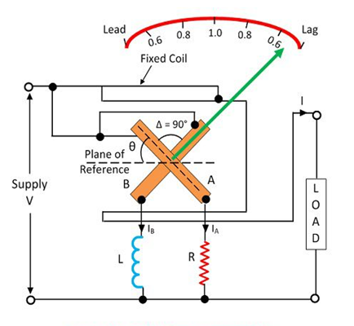

Fig. 3.8Single Phase Electrodynamometer Power Factor Meter

The deflecting torque acting on coil B is expressed as

equation-2-power-factor-meter-1

The deflecting torque is acting on the clockwise direction.

power-factor-meter-equation-3

The value of maximum mutual inductance is same between both the deflecting equations.

This torque acts on anti-clockwise direction. The above equation shows that the deflecting torque is equal to the phase angle of the circuit.

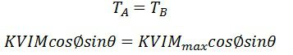

**3.6 THREE PHASE ELECTRODYNOMETER POWER FACTOR METER**

**construction**

The construction of the three phase meter is shown in the figure .The electrodynamometer is only useful for the balanced load. The moving coil is placed at an angle of 120º. They are connected across different phases of the supply circuit. Both the coil has a series resistance.

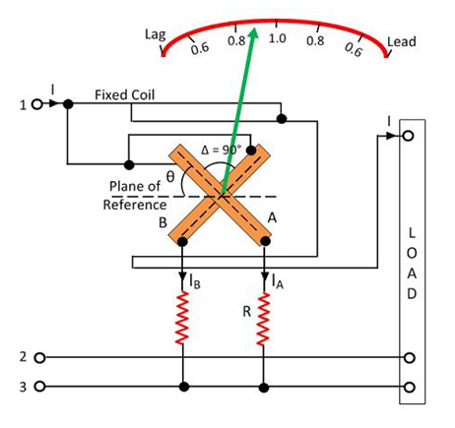

Fig. 3.9 Three Phase Electro dynometer Power Factor Meter

Let  Φ – phase angle of the circuit.  
θ – angular deflection from the plane of reference.

Torque acting on coil A is

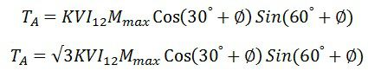

Torque acting on coil B is

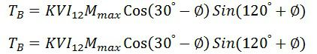

The torque TA and TB are acting on the opposite directions.

power-factor-meter-equation-9

Thus the angular deflection of the coil is directly proportional to the phase angle of the circuit.

**3.7 MOVING IRON POWER FACTOR METER**

The moving iron instrument is divided into two categories. They are the rotating magnetic field to some alternating fields. A Rotating Field Power factor Meter – The power factor meter has three fixed coils, and their axes are 120º displaced from each other. The axes are intersecting each other. he coils are connected to the three phase supply with the help of the current transformer

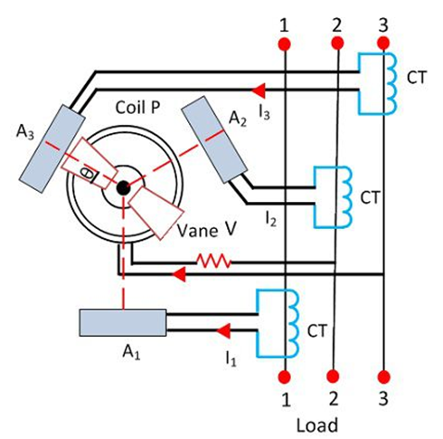

Fig. 3.10 Rotating Field Power factor Meter

P is the fixed coil connected in series with the high resistance circuit across the phases 2 and 3. There is an iron cylinder across coil P. The two iron vanes are fixed to the cylinder. The spindles also carry damping vanes and pointer. The phasor diagram of the power factor meter is shown in the figure**.**

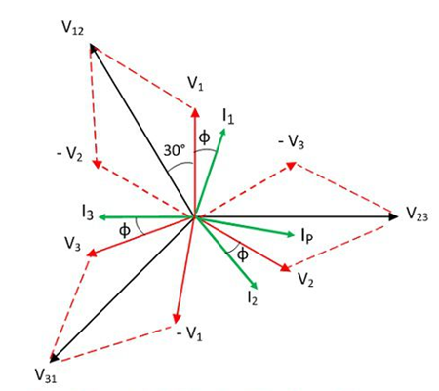

Fig. 3.11 The phasor diagram of the power factor meter

The total torque of the meter is zero for steady state deflection.

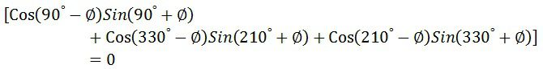

The coil P and the iron cylinders generate the alternating flux which interacts with the flux of the fixed coils. The interaction of the coil generates the moving system which determined the phase angle of the current. The vanes of the power factor meter are magnetized by the current of the moving coil which is in phase with the system line voltage.

**Advantages of Moving Iron power Power Factor meter**

1. The meter requires large working force as compared to the electrodynamometer type meter.
2. The coils of the moving iron instruments are fixed permanently.
3. The range of the scale extends up to 360º.
4. The construction of the meter is robust and simple.
5. The moving iron instrument is cheap as compared to electrodynamic meter.

**3.8 ENERGY METER**

**Definition:** The meter which is used for measuring the energy utilises by the electric load is known as the energy meter.

The energy is the total power consumed and utilised by the load at a particular interval of time. It is used in domestic and industrial AC circuit for measuring the power consumption. The meter is less expensive and accurate.

**3.8.1 Construction of Energy Meter**

The energy meter has four main parts. They are the

Driving System

Moving System

Braking System

Registering System

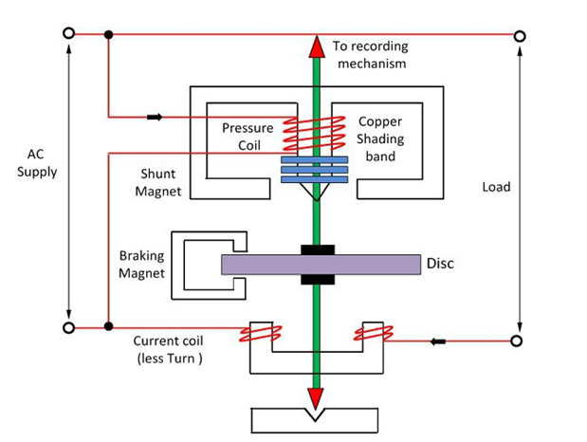

Fig. 3.12 Induction type energy meter

1. **Driving System**

The electromagnet is the main component of the driving system. The core of the electromagnet is made up of silicon steel lamination. The driving system has two electromagnets. The upper one is called the shunt electromagnet, and the lower one is called series electromagnet. The series electromagnet is excited by the load current flow through the current coil. The coil of the shunt electromagnet is directly connected with the supply and hence carry the current proportional to the shunt voltage. This coil is called the pressure coil. The centre limb of the magnet has the copper band. These bands are adjustable. The main function of the copper band is to align the flux produced by the shunt magnet in such a way that it is exactly perpendicular to the supplied voltage.

1. **Moving System**

The moving system is the aluminum disc mounted on the shaft of the alloy. The disc is placed in the air gap of the two electromagnets. The eddy current is induced in the disc because of the change of the magnetic field. This eddy current is cut by the magnetic flux. The interaction of the flux and the disc induces the deflecting torque. When the devices consume power, the aluminum disc starts rotating, and after some number of rotations, the disc displays the unit used by the load. The number of rotations of the disc is counted at particular interval of time. The disc measured the power consumption in kilowatt hours.

1. **Braking system**

The permanent magnet is used for reducing the rotation of the aluminum disc. The aluminum disc induces the eddy current because of their rotation. The eddy current cut the magnetic flux of the permanent magnet and hence produces the braking torque.This braking torque opposes the movement of the disc, thus reduces their speed. The permanent magnet is adjustable due to which the braking torque is also adjusted by shifting the magnet to the other radial position.

1. **Registration (Counting Mechanism)**

The main function of the registration or counting mechanism is to record the number of rotations of the aluminum disc. Their rotation is directly proportional to the energy consumed by the loads in the kilowatt hour. The rotation of the disc is transmitted to the pointers of the different dial for recording the different readings. The reading in kWh is obtained by multiply the number of rotations of the disc with the meter constant.

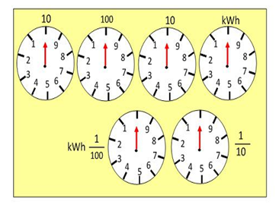

Fig. 3.13 counting system

**3.8.2 Working of the Energy Meter**

The energy meter has the aluminum disc whose rotation determines the power consumption of the load. The disc is placed between the air gap of the series and shunt electromagnet. The shunt magnet has the pressure coil, and the series magnet has the current coil.

The pressure coil creates the magnetic field because of the supply voltage, and the current coil produces it because of the current.

The field induces by the voltage coil is lagging by 90º on the magnetic field of the current coil because of which eddy current induced in the disc. The interaction of the eddy current and the magnetic field causes torque, which exerts a force on the disc. Thus, the disc starts rotating.

The force on the disc is proportional to the current and voltage of the coil. The permanent magnet controls Their rotation. The permanent magnet opposes the movement of the disc and equalises it on the power consumption. The cyclometer counts the rotation of the disc.

**Theory of Energy Meter**

The pressure coil has the number of turns which makes it more inductive. The reluctance path of their magnetic circuit is very less because of the small length air gap. The current Ip flows through the pressure coil because of the supply voltage, and it lags by 90º.

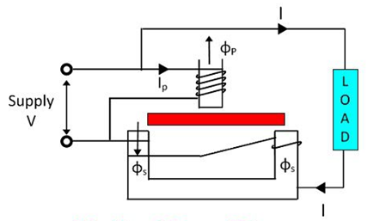

Fig. 3.14 Energy Meter

The Ip produces the two Φp which is again divided into Φp1 and Φp2. The major portion of the flux Φp1 passes through the side gap because of low reluctance. The flux Φp2 goes through the disc and induces the driving torque which rotates the aluminum disc.

The flux Φp is proportional to the applied voltage, and it is lagged by an angle of 90º. The flux is alternating and hence induces an eddy current Iep in the disc.

The load current passes through the current coil induces the flux Φs. This flux causes the eddy current Ies on the disc. The eddy current Ies interacts with the flux Φp, and the eddy current Iep interacts with Φs to produce the another torque. These torques are opposite in direction, and the net torque is the difference between these two.

The phasor diagram of the energy meter is shown in the figure below.

Let  
V – applied voltage  
I – load current  
∅ – the phase angle of load current  
Ip – pressure angle of load  
Δ – the phase angle between supply voltage and pressure coil flux  
f – frequency  
Z – impedance of eddy current  
∝ – the phase angle of eddy current paths  
Eep – eddy current induced by flux  
Iep – eddy current due to flux  
Eev – eddy current due to flux  
Ies – eddy current due to flux

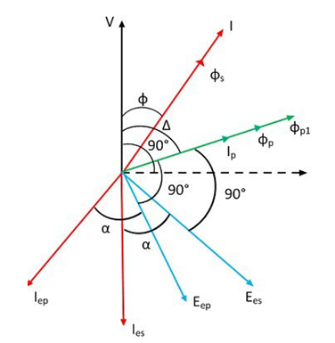

Fig. 3.15 phasor diagram of the energy meter

The net driving torque of the dis is expressed as

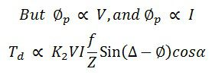

where K1 – constant

Φ1 and Φ2 are the phase angle between the fluxes. For energy meter, we take Φp and Φs.

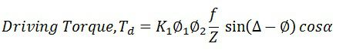

β – phase angle between fluxes Φp and Φp = (Δ – Φ), therefore

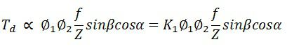

If f, Z and α are constants,

equation-44

If N is steady speed, braking torque

equation-6

At steady state, the speed of the driving torque is equal to the braking torque.

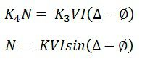

If Δ = 90º,

Speed,

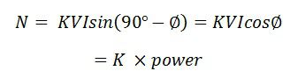

The speed of the rotation is directly proportional to the power.

equation-9

If Δ = 90º, total number of revolutions

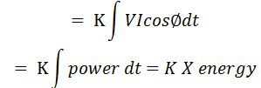

The three phase energy meter is used for measuring the large power consumption.

**3.8.3** Creeping in Energy Meter

**Definition:**

Creeping in energy meter is the phenomenon in which the aluminum disc rotates continuously when only the voltage is supplied to the pressure coil, and no current flows through the current coil.

In other words, the creeping is the kind of error in which the energy meter consumes a very small amount of energy even when no load is attached to the meter.

**Prevention of Creeping**

The creeping is avoided by drilling the hole in the disc. The holes are diametrically opposite to each other. The aluminum disc stops rotating even when the small edge of the disc come under the pole of the magnet. The holes will limit the revolution of the disc.

1. **Practice Quiz**

1. Power is ___________  
a) rate of doing work  
b) rate of producing voltage  
c) rate of generating current  
d) rate of overcoming friction  
Answer: a  
Explanation: Power is defined as the rate of doing work. The unit of power is watt. In D.C. circuits, power is the product of the voltage consumed and the current flowing through a circuit. P = VI watts.

2. In A.C. circuits, power consumed is ________  
a) product of voltage and current  
b) it depends on the p.f. of the circuit in addition to voltage and current  
c) it depends on the supply voltage  
d) it depends on the magnitude of the circuit current  
Answer: b  
Explanation: In a A.C. circuit, the power consumption is given by the expression,  
P=VI cos∅  
where, V is the voltage across the circuit  
I is the current flowing through the circuit  
cos∅ is the power factor of the circuit.

3. In D.C. circuits, power is measured using ________  
a) ohmmeter and galvanometer  
b) ohmmeter and voltmeter  
c) ammeter and voltmeter  
d) ammeter and galvanometer  
Answer: c  
Explanation: An ammeter is used to measure current flowing through a circuit, while a voltmeter is used to measure the voltage across the circuit. Hence in D.C. circuits, ammeter and voltmeter are used to measure power.

4. In A.C. circuits, power is measured using  
a) voltmeter  
b) ammeter  
c) ohmmeter  
d) wattmeter

Answer: d  
Explanation: A.C. circuits make use of power factor of the circuit in addition to the current flowing through the circuit and the voltage across the circuit. As a result, a wattmeter is used to measure A.C. power.

5. A dynamometer type wattmeter consists of ________  
a) only potential coil  
b) potential and current coils  
c) only current coil  
d) no coils  
Answer: b  
Explanation: Dynamometer type wattmeter is used for the measurement of A.C. as well as D.C. power. It consists of a fixed coil forming the current coil whereas the moving coil forms the potential coil.

6. In a Dynamometer type wattmeter, the fixed coil is split into ________  
a) 4  
b) 3  
c) 2  
d) 1  
Answer: c  
Explanation: When a Dynamometer type wattmeter is used for the measurement of A.C. power, the fixed coil is split into two equal parts. The two parts are air-cored to avoid hysteresis loss.

7. When a current carrying coil is placed in the magnetic field.  
a) no force is exerted  
b) voltage is produced  
c) power is generated  
d) a force is exerted  
Answer: d  
Explanation: When the current carrying coil of a Dynamometer type wattmeter is placed in the magnetic field of another current carrying coil, the moving coil experiences a force. As a result a deflection torque is generated and the moving coil undergoes deflection.

8. When the moving coil in a Dynamometer type wattmeter deflects  
a) pointer moves  
b) pointer doesn’t move  
c) current flows  
d) voltage is generated  
Answer: a  
Explanation: In a Dynamometer type wattmeter, when the moving coil deflects the pointer moves over the scale. The pointer then comes back to rest at a point where the deflecting torque equals the controlling torque.

9. Pressure coil of a wattmeter  
a) has capacitance and inductance  
b) has inductance and resistance  
c) has resistance and capacitance  
d) has only inductance

Answer: a  
Explanation: Series resistance R consists of inter turn capacitance. As a result, the pressure coil of the wattmeter consists of capacitance in addition to inductance.

10. What is the effect of capacitance on wattmeter reading?  
a) aiding the inductance  
b) opposite to that of inductance  
c) aiding the capacitance  
d) opposite to that of resistance  
Answer: b  
Explanation: For lagging power factor of the load, the wattmeter reading is more. As a result, the wattmeter shows a reading opposite to that of the inductance.

11. Dynamometer type wattmeter has _________  
a) strong magnetic field  
b) intermediate magnetic field  
c) weak magnetic field  
d) no magnetic field

Answer: c  
Explanation: Dynamometer type wattmeter consists of a weak magnetic field. It is affected by stray magnetic fields. As a result, wattmeters are shielded to offset effects of stray magnetic fields.

12. Wattmeter reading has errors induced by _________  
a) resistance  
b) self-capacitance  
c) self-inductance  
d) mutual inductance  
Answer: d  
Explanation: Due to mutual inductance between the current and pressure coil in a wattmeter, errors are introduced. Errors are negligible at power frequencies whereas they have a considerable value at higher frequencies.

13. Current in a pressure coil of the Dynamometer type wattmeter  
a) lags the applied voltage  
b) leads the applied voltage  
c) is in phase with the applied voltage  
d) there is a phase difference of 90 degrees

Answer: a  
Explanation: The current through the pressure coil is in phase with the applied voltage in an ideal wattmeter. The pressure coil is assumed to be purely resistive. Practically, the pressure coil has a small inductance L. As a result the current lags the applied voltage by a certain angle.  
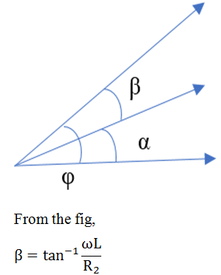

where, R2 = r2 + R = total resistance of the pressure coil  
r2 = resistance of pressure coil  
R = series resistance with the pressure coil  
I1 = load current.

14. Wattmeters are compensated for errors due to inductance by _________  
a) using a series capacitor  
b) using a parallel capacitor  
c) using a series resistance  
d) using a parallel resistance  
Answer: b  
Explanation: Wattmeters are compensated for errors caused by the inductance of pressure coil through the connection of a suitable parallel capacitor with multiplier resistance R.  
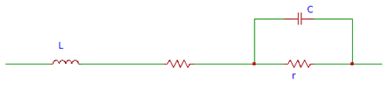  
Fig illustrates that the total impedance of the pressure coil circuit Z2 equals the total resistance of the pressure coil circuit namely R2.

15. What is the effect of frequency on the torque of a moving system?  
a) torque is half of the frequency  
b) torque is twice the frequency  
c) torque is thrice the frequency  
d) torque is four times the frequency  
Answer: b  
Explanation: In a wattmeter, the torque of the moving system is affected by the frequency. Torque is twice the natural frequency with respect to the supply voltage. As a result of this, pointer in the measurement scale vibrates causing difficulty in reading.

16. In an ordinary dynamometer, the deflecting torque is _________  
a) small  
b) medium  
c) large  
d) very large  
Answer: a  
Explanation: The deflecting torque in an ordinary dynamometer is small. The current and pressure coils are excited. The measurement of power factor is inaccurate.

17. Errors are introduced by ________  
a) capacitance  
b) inductance  
c) resistance  
d) impedance  
Answer: b  
Explanation: At low power factors in an ordinary dynamometer type wattmeter, the errors are caused due to inductance of the pressure coil.

18. Power coil has a low value of ________  
a) inductance  
b) capacitance  
c) resistance  
d) impedance  
Answer: c  
Explanation: In a low power factor dynamometer type wattmeter, the pressure coil is designed in order to have a low value of resistance. The current flowing through the pressure coil is increased in order to raise the operating torque.

19. Resistance of pressure coil in a low power factor dynamometer type wattmeter is  
a) once time  
b) three times  
c) hundred times  
d) ten times

Answer: d  
Explanation: In a low power factor dynamometer type wattmeter, pressure coil has a resistance value that is one tenth of the actual with respect to unity power wattmeters. This is done in order to ensure a reasonable amount of torque at low power factors.

20. Low power factor wattmeters are designed to ________  
a) have a low torque  
b) have a high torque  
c) have a medium torque  
d) have no torque  
Answer: a  
Explanation: Low power factor wattmeters have a low value of control torque. They provide full scale deflection for low values of power factors of the order of 0.1.

21. Power loss in the current coil is ________  
a) less  
b) more  
c) intermediate  
d) very less  
Answer: b  
Explanation: Low power factor circuits have low power. Current coil constitutes a high current. As a result, the power loss in the current coil is high. The reading obtained from the wattmeter is prone to errors.

22. Induction type instruments are used for ____________  
a) A.C. measurements  
b) D.C. measurements  
c) Resistance measurements  
d) Voltage measurements  
Answer: a  
Explanation: A.C. measurements are made using Induction type instruments. Induction type energy meter is used to measure the energy that is consumed in A.C. circuits only.

23. Driving system in an induction type single phase energy meter consists of _________  
a) one magnet  
b) two electromagnets  
c) five electromagnets  
d) ten magnets  
Answer: b  
Explanation: In an induction type single phase energy meter, the driving system consists of two electromagnets, namely series electromagnet and shunt electromagnet.

24. Series electromagnet consists of _________  
a) L shaped laminations  
b) T shaped laminations  
c) U shaped laminations  
d) Y shaped laminations

Answer: c  
Explanation: The driving system of an induction type single phase energy meter consists of U shaped laminations made of silicon steel. The laminations are insulated from one another and pressed to form the core.

25. Shunt magnet consists of _________  
a) N shaped laminations  
b) E shaped laminations  
c) S shaped laminations  
d) M shaped laminations

Answer: d  
Explanation: The driving system of an induction type single phase energy meter consists of M shaped laminations made of silicon steel. The laminations are insulated from one another and pressed to form the core of the shunt magnet.

26. Shunt magnet has _________  
a) large turns of wire  
b) small turns of wire  
c) medium turns of wire  
d) no turns or wires

Answer: a  
Explanation: The central limb of the shunt magnet has a large number of turns. It connected across the supply and is known as the voltage coil or potential coil. It is excited using a current value that is proportional to the applied voltage.

27. Moving system of the induction type single phase energy meter has _________  
a) heavy aluminum disc  
b) light aluminium disc  
c) medium aluminium disc  
d) no aluminium disc

Answer: b  
Explanation: Aluminium disc is provided in the air gap between the series and shunt magnets. Jewel bearings support the spindle. Hence the moving system in a induction type single phase energy meter consists of light aluminium disc.

28. Braking system consists of _________  
a) bar magnet  
b) temporary magnet  
c) permanent magnet  
d) super magnet

Answer: c  
Explanation: In an induction type single phase energy meter, edge of the aluminium disc consists of a permanent magnet also known as a brake magnet. E.m.f is induced in the aluminium disc when it rotates as a result of the magnetic field produced by the brake magnet.

29. What is the effect of eddy currents in the aluminium disc?  
a) varies by a factor of twice the disc length  
b) independent of the disc speed  
c) varies by a factor of four times the disc size  
d) proportional to the disc speed

Answer: d  
Explanation: The eddy currents induced in an aluminium disc vary in proportion to the speed of the disc. As a result the braking torque exerted on the disc varies in proportion to the speed.

30. Energy meter reads correctly when  
a) torque is small  
b) torque is large  
c) torque is medium  
d) torque is zero

Answer: a  
Explanation: The reading in an energy meter is obtained correctly when the torque value is small at low loads. It is independent of the load on the meter an acts in the same direction as the driving torque.

31. Small torque for energy meter is provided  
a) by a supply  
b) by a shading loop  
c) by unshaded loop  
d) by a transformer

Answer: b  
Explanation: Friction can be compensated in an energy meter by making use of a shading loop. It is placed between the central limb of the shunt magnet and a disc. Figure below illustrates the same.  
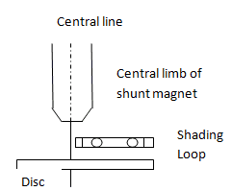

32. Friction torque is eliminated by _________  
a) using lubricating oil  
b) by suspending the components in air  
c) by adjusting position of limb  
d) by using steel alloy components

Answer: c  
Explanation: We can eliminate the friction torque completely by adjusting the position of the shading loop. This enables in providing compensation for the frictional torque.

33. At full load, disc  
a) partially revolves and then stops  
b) continuously revolves  
c) does not revolve at all  
d) revolves in an alternating fashion

Answer: b  
Explanation: When an energy meter is operated in full load condition, disc revolves continuously due to the field of the series magnet. As a result, an e.m.f is induced in the disc.

34. Self braking torque is _________  
a) proportional to cube of load current  
b) proportional to load current  
c) proportional to square of load current  
d) proportional to reciprocal of load current

Answer: c  
Explanation: In an energy meter, the self braking torque is dependent on the square of the load current. As a result the disc rotates at a slightly slower speed at high value of loads.

35. Self braking action is minimised by _________  
a) maintaining high speed for disc  
b) maintaining medium speed for disc  
c) keeping the disc at rest  
d) maintaining low speed for disc

Answer: d  
Explanation: In an energy meter we can minimise or eliminate the self braking action by keeping the disc speed as low as possible at full load condition. This is achieved by maintaining the flux due to the current coil smaller than that due to the shunt coil. Figure below shows the compensating device.  
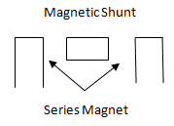

36. Overload compensating devices is _________  
a) in the form of a magnetic shunt  
b) in the form of a series magnet  
c) in the form of a transformer  
d) in the form of a supply

Answer: a  
Explanation: Magnetic shunt reaches saturation at overloads. As a result, its permeability reduces. Hence the overload compensating device takes the form of a magnetic shunt.

37. Magnitude of flux in an energy meter varies __________  
a) due to abnormal currents and voltages  
b) due to high resistance and inductance values  
c) due to change in the transformer turns  
d) due to the induced e.m.f in the windings

Answer: a  
Explanation: In the driving system of an energy meter, magnitude of flux can be incorrect as a result of abnormal values of currents and voltages. This occurs due to change in the resistance of the pressure coil circuit.

38. Energy meter creeps __________  
a) due to change in supply  
b) due to reversal in polarity of voltage  
c) due to asymmetry in magnetic circuit  
d) due to turns ratio of transformer

Answer: c  
Explanation: In an energy meter, when the magnetic circuit is asymmetrical, a driving torque is produced. As a result of this driving torque, the energy meter creeps.

39. Supply voltage in an energy meter is __________  
a) constant always  
b) zero always  
c) depends on the load  
d) can fluctuate

Answer: d  
Explanation: Generally the supply voltage is constant in an energy meter. It can fluctuate as a result of unavoidable reasons leading to errors in the reading of the energy meter.

40. How is the flux of shunt coil related to voltage?  
a) flux is proportional to square of voltage  
b) directly proportional  
c) inversely proportional  
d) independent of each other

Answer: a  
Explanation: In an energy meter, the supply voltage may fluctuate as a result of unavoidable reasons leading to errors in the reading. Supply voltage causes the shunt flux to induce an e.m.f in the disc. This is results in a self braking torque proportional to square of the voltage.

41. How can temperature effect be compensated in an energy meter?  
a) Through heat sinks  
b) by a temperature shunt  
c) by using resistance  
d) by using a coolant

Answer: b  
Explanation: The resistance of the copper and aluminium parts in an energy meter increase with an increase in the temperature. As a result the disc rotates with a speed that is higher than actual. Temperature effects can be compensated by making use of a temperature shunt on the brake magnet.

42. Creeping is avoided by __________  
a) reversing the polarity of the voltage  
b) drilling two diametrically opposite holes  
c) holding the disc  
d) increasing the friction

Answer: b  
Explanation: In an energy meter, creeping causes the disc to rotate even when there is no current flowing. By drilling two diametrically opposite holes under the edge of the poles of a shunt magnet, rotation of the disc is limited to a minimum value.

43. In some energy meters, creeping can be avoided by __________  
a) attaching small gold pieces  
b) attaching small aluminium pieces  
c) attaching small iron pieces  
d) attaching small zinc pieces

Answer: c  
Explanation: By attaching some iron pieces to the edge of the disc, creeping can be limited in some energy meters. Force of attraction that is experienced by the brake magnet as a result of the iron piece is enough to eliminate the creeping.

44.The resistance in the circuit of the moving coil of a dynamometer wattmeter should be  
(a) almost zero  
(b) low  
(c) high  
(d) none of the above  
Ans: c

45. A dynamometer wattmeter can be used for  
(a) both D.C. and A.C.  
(b) D.C. only  
(c) A.C. only  
(d) any of the above  
Ans: a  
46. An induction wattmeter can be used for  
(a) both D.C. and A.C.  
(6) D.C. only  
(c) A.C. only  
(d) any of the above  
Ans: b  
47. The pressure coil of a wattmeter should be connected on the supply side of the current coil when  
(a) load impedance is high  
(b) load impedance is low  
(c) supply voltage is low  
(d) none of the above  
Ans: a  
48. In a low power factor wattmeter the pressure coil is connected  
(a) to the supply side of the current coil  
(b) to the load side of the current coil  
(c) in any of the two meters at connection  
(d) none of the above  
Ans: b  
49. In a low power factor wattmeter the compensating coil is connected  
(a) in series with current coil  
(b) in parallel with current coil  
(c) in series with pressure coil  
(d) in parallel with pressure coil  
Ans: c  
50. In a 3-phase power measurement by two wattmeter method, both the watt meters had identical readings. The power factor of the load was  
(a) unity  
(6) 0.8 lagging  
(c) 0.8 leading  
(d) zero  
Ans: a  
51. In a 3-phase power measurement by two wattmeter method the reading of one of the wattmeter was zero. The power factor of the load must be  
(a) unity  
(b) 0.5  
(c) 0.3  
(d) zero  
Ans: b  
52. The adjustment of position of shading bands, in an energy meter is done to provide  
(a) friction compensation  
(b) creep compensation  
(c) braking torque  
(d) none of the above  
Ans: a

53. A power factor meter has  
(a) one current circuit and two pressure circuits  
(b) one current circuit and one pressure circuit  
(c) two current circuits and one pressure circuit  
(d) none of the above  
Ans: a  
54. The two pressure coils of a single phase power factor meter have  
(a) the same dimensions and the same number of turns  
(b) the same dimension but different number of turns  
(c) the same number of turns but different dimensions  
(d) none of the above  
Ans: a  
55. In a single phase power factor meter the phase difference between the currents in the two pressure coils is   
(a) exactly 0°  
(b) approximately 0°  
(c) exactly 90°  
(d) approximately 90°  
Ans: c  
56. In a dynamometer 3-phase power factor meter, the planes of the two moving coils are at  
(a) 0°  
(b) 60°  
(c) 90°  
(d) 120°  
Ans: d

57. Which of the following error may arise in wattmeter if it is not compensated for the errors?

a) Voltage coil inductance  
b) Voltage coil capacitance  
c) Eddy currents  
d) (a), (b) and (c)  
  
Ans: (d)

58. Which of the following is methods is the commonest method of measuring three balanced or unbalanced power?

a) One wattmeter method  
b) Two wattmeter method  
c) Three wattmeter method  
d) Ammeter method  
  
Ans: (b)

59. One-Wattmeter method is used to measure

a) The power when load is balance in three phase circuit  
b) The power when load is unbalanced in three phase circuit  
c) (a) or (b)  
d) Single phase power with balanced load  
  
Ans: (a)

60. The reactive power can be measured with wattmeter when voltage across voltage coil is adjusted to be out of phase with the current by

a) 90°  
b) 180°  
c) 45°  
d) 0°  
e) 120°  
  
Ans: (a)

61. Which of the following devices are required to measure three phase balance power?

a) One wattmeter  
b) One wattmeter and one voltage transformer of 1:1 ratio  
c) One wattmeter and two current transformers of 1:1 ratio  
d) Either (b) or (c)  
  
Ans: (d)

62. The total power P measured in Y star three-phase circuit is given by

a) P = 3VI cos ⁡ϕ  
b) P = √I cos ⁡ϕ  
c) P = √3VI cos ⁡ϕ  
d) P = √2VI cos⁡ ϕ  
  
Ans: (c)

Where V and I are the line voltage and line current respectively.

63.In the above question, the power in delta three-phase circuit is given by

a) P = 3 VI cos ⁡ϕ  
b) P = √3 VI cos ⁡ϕ  
c) P = √2 VI cos ⁡ϕ  
d) P = √3 VI sin ⁡ϕ  
  
Ans: (b)

64. The dynamometer wattmeter can be used to measure

a) AC power only  
b) DC power only  
c) AC or DC power  
d) AC power of single-phase circuits  
  
Ans: (c)

65.The pointer deflection of wattmeter is proportional to

a) Torque produced in the wattmeter b) Voltage  
c) Current  
d) Power  
e) (a) or (b)  
  
Ans: (e)

66. Induction wattmeters can be used to measure

a) AC power  
b) DC power  
c) AC or DC power  
d) AC power of single phase only  
  
Ans: (a)

67. Motor meters can be used to measure AC or DC

a) Watt-hours  
b) Ampere-hours c) Current  
d) Voltage  
e) (a) or (b)  
  
Ans: (c)

68. Motor meter can be used to measure

a) AC energy  
b) DC energy  
c) AC or DC energy  
d) None of the above  
  
Ans: (d)

69. The one “unit” of energy measured in AC circuit is equivalent to

a) One watt-hour  
b) One kilowatt-hour  
c) One watt  
d) One kilowatt  
e) One joule  
  
Ans: (b)

70. Which of the following energy meter is universally accepted to measure AC encrgy?

a) Motor meter  
b) Induction type meter  
c) Mercury motor meter  
d) Reason Electrostatic meter  
  
Ans: (b)

71. Which of the following loads are dangerous for thermal heating of wattmeter even if meter reading is low?

a) Loads with high value of power factor  
b) Loads with low value of power factor  
c) Chokes  
d) (b) and (c)  
  
Ans: (d)

72. If the reading of two wattmeters in two-wattmeter method of power measurement are 4 kW and 3 kW respectively and the latter reading being obtained after reversing connection of the current coil of wattmeter, what will be the power?

a) 6 kW  
b) 1 kW  
c) 4 kW  
d) 5 kW  
e) 7 kW  
Ans: (b)

73.In a low power factor wattmeter the compensating coil is connected

   A. In series with current coil

   B. In parallel with current coil

   C. In series with pressure coil

   D. In parallel with pressure coil

Answer:C

74. In a 3-phase power measurement by two wattmeter method, both the wattmeters had identical readings. The power factor of the load was

   A. Unity

   B.0.8 lagging

   C.0.8 leading

   D.Zero

Answer:A.Unity

75. In a 3-phase power measurement by two wattmeter method the reading of one of the wattmeter was zero. The power factor of the load must be

   A. Unity

   B.0.5

   C.0.3

   D. Zero

Answer: B.0.5

76. Wattmeter cannot be designed on the principle of

   A. Electrostatic instrument

   B. Thermocouple instrument

   C. Moving iron instrument

   D. Electrodynamics instrument

Answer: C. Moving iron instrument

77.The readings of a dynamometer type wattmeter can be highly erratic at

   A. Low frequencies

   B. Fluctuating loads

   C. Low power factors

   D. High voltages

Answer: C. Low power factors

78. A dynamometer type wattmeter has

   A. Square law scale

   B. Non-linear scale

   C. Logarithmic scale

   D. Uniform scale

Answer: D. Uniform scale

79. Which of the following methods is used to shield a dynamometer type wattmeter against stray fields

   A. Meter components are made of non-magnetic materials

   B. Meter is housed in a soft iron case

   C. Neutral wire connection is provided

   D. Meter is earthed

Answer: B. Meter is housed in a soft iron case

80. A wattmeter will be free from the effects of power factor and frequency variations in case

   A. Voltage coil resistance is zero

   B. Damping is not provided

   C. Pressure coil inductance is zero

   D.A capacitance is connected in parallel to pressure coil

Answer: A. Voltage coil resistance is zero

81. The minimum number of watt meters required to measure power in an unbalanced three-wire system is

   A. One

   B. Two

   C. Three

   D. Four

Answer: B. Two

82. An induction wattmeter measures

   A. Only the true power

   B. The reactive power

   C. The apparent power

   D. The true power and the reactive power

Answer: A. Only the true power

83. Obtaining correct reading from the energy meter requires  
a) low resistance and iron losses  
b) high resistance and iron losses  
c) high resistance and low iron losses  
d) low resistance and high iron losses

Answer: a  
Explanation: In order to obtain exact reading for the energy consumed by a load using an energy meter, we require the pressure coil to have a low value of resistance and low iron losses.

84. Phase angle can be made 90 degrees using  
a) lead circuit  
b) lag circuit  
c) special design  
d) transformer

Answer: c  
Explanation: Phase angle in an energy meter can be made approximately 90 degrees by making use of a special design in the energy meter.

85. Copper shading bands are _________  
a) placed as resistance  
b) placed as wire  
c) placed outside the central limb  
d) placed around central limb

Answer: d  
Explanation: The central limb of a shunt magnet consists of copper shading bands. They can be moved up or down by making use of the central limb. Figure below illustrates the use of copper shading bands.  
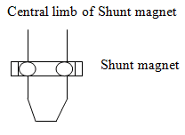

86. As copper shading bands move up  
a) more flux is induced  
b) less flux is induced  
c) intermediate flux is induced  
d) no flux is induced

Answer: a  
Explanation: When the copper shading bands are moved up the central limb, more flux is induced. As a result the difference in angle between the phase and voltage increases. The angle can be made approximately equal to 90 degrees.

87. Shunt flux is made to lag the applied voltage using  
a) lead circuit  
b) lag adjustment  
c) lead-lag circuit  
d) transformer

Answer: b  
Explanation: We make use of shading coil on the central limb of a shunt magnet and shading bands in order to make the shunt flux to lag the applied voltage by almost 90 degrees.

88. At overloads, magnetic shunt ________  
a) aids the series flux  
b) diverts series flux  
c) maintains zero flux  
d) disables the shunt flux

Answer: b  
Explanation: As the magnetic shunt reaches saturation at overloads, magnetic shunt diverts the flux due to series magnet. As a result a large portion of the flux appears in the gap of the air disc. This compensates the self braking torque.

1. A wattmeter consists of a current coil and a potential coil.  
a) True  
b) False

Answer: a  
Explanation: Power in single phase A.C. circuits are measured by making use of a wattmeter. It consists of a current coil (cc) and a potential coil (pc). Current coil is connected with the load while the potential coil is connected across the supply.

2. Controlling torque is provided by gold springs.  
a) True  
b) False

Answer: b  
Explanation: In a Dynamometer type wattmeter, controlling torque is provided by two phosphor bronze hair springs. They act as leads to the current flowing through the coil. Also air friction damping is used.

3. Wattmeter reading is not affected by temperature.  
a) True  
b) False

Answer: b  
Explanation: Wattmeter reading is affected by change in temperature. Resistance of the pressure coil and the spring stiffness are affected by the changes in temperature. Effects caused by these two effects oppose each other and neutralize.

4. Eddy currents are induced in solid metal parts within the thickness of the conductor.  
a) True  
b) False

Answer: a  
Explanation: Eddy currents produce their own field. They affect the magnitude and phase of the current flowing through the current coil. This leads to errors. As a result, the wattmeter reads low values for lagging power factors and high values for leading power factors.

5. Pressure coil has no error.  
a) True  
b) False  
Answer: b  
Explanation: Pressure coil has an error induced due to inductance. It is given by the relation EI sinΦ tanβ. As value of Φ is large for low value of power factor, the error is high in a pressure coil.

6. Error in a pressure coil can be compensated.  
a) True  
b) False

Answer: a  
Explanation: In a low power factor wattmeter, by connecting a capacitor of value C across a portion of the resistance R in the circuit the error in the pressure coil can be compensated.

7. AC potentiometer can be used to measure the loss in an iron ring made up of thin stampings.

a) True  
b) False  
  
Ans: (a)

8.An energy meter produces a flux of ∅ when connected to a supply V.  
a) True  
b) False

Answer: a  
Explanation: Flux ∅ is produced in an energy meter when it is connected to a supply voltage of magnitude V volts. Since the potential coil is highly inductive, current and flux lag the voltage by 90°.

9. Driving torque is small and is adjustable.  
a) True  
b) False

Answer: a  
Explanation: Interaction between the parts of the shaded and unshaded fluxes, obtained through a shading loop leads to a small driving torque. The value of the torque can be adjusted through lateral movement of the loop.

10. Frictional errors are dominant in an energy meter.  
a) True  
b) False

Answer: a  
Explanation: Frictional errors exist in an energy meter at the top as well as bottom surfaces even at low value of loads. Even when the disc is rotating slowly errors due to friction exist in an energy meter.

11. Phase angles in an energy meter cannot be incorrect.  
a) True  
b) False

Answer: b  
Explanation: In an energy meter, phase angle errors occur as a result of improper adjustments of lag condition, abnormal frequencies etc,. Due to temperature, changes in resistance values also lead to error in the phase angle.

12.Disc rotates slowly in some energy meters.  
a) True  
b) False

Answer: a  
Explanation: Even when there is no current flow through the energy meter, disc rotates slowly. This is known as creeping. This is occurs as a result of the over compensation provided for friction.

13.The change of frequency affects the circuit parameters of wattmeter connected to measure power of three-phase AC system

a) True  
b) False  
  
Ans: (b)

14. The eddy current torque on a metallic disc rotating between poles of permanent magnet in energy meter is directly proportional to the angular velocity of the disc.

a) True  
b) False  
  
Ans: (a)

15. The energy meter always measures the load energy correctly.  
a) True  
b) False  
View Answer

Answer: b  
Explanation: When the difference in phase angles between the shunt magnetic flux and the applied voltage is 90 degrees (lagging), the reading of the load energy obtained from an energy meter is correct.

16. Shading coil consists of many thick turns.  
a) True  
b) False

Answer: b  
Explanation: On the central limb of a shunt magnet we can make use of a shading coil. The shading coil consists of a few fairly thick turns. Figure below shows a shading coil on the central limb of the shunt magnet.  
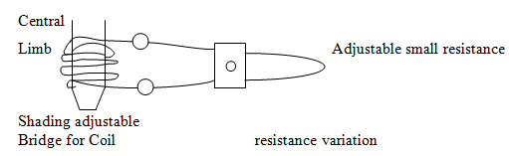

1. **Assignments**

|  |  |  |  |
| --- | --- | --- | --- |
| S.No | Question | BL | CO |
| 1 | Explain the Construction and Working Principle of electro dynamometer type wattmeter? | **2** | **1** |
| 2 | Construction and Working Principle of Electrodynamometer Type Wattmeter | **2** | **1** |
| 3 | Give Advantages of Electrodynamometer Type Wattmeter and Errors in Electrodynamometer Type Wattmeter. | **2** | **1** |
| 4 | Explain various types of Power Factor Meters with neat diagrams? | **2** | **1** |
| 5 | Explain about watt hour meter ? Explain about three phase energy meter and explain various errors ? | **3** | **1** |
| 6 | Explain the Construction and Working Principle of electro dynamometer type three phase wattmeter? | **3** | **1** |

1. **Part A- Question & Answers**

|  |  |  |  |
| --- | --- | --- | --- |
| S.No | Question& Answers | BL | CO |
| 1 | **What are the constructional parts of dynamometer type wattmeter?**  **Ans:** Fixed coil  Moving Coil  Current limiting resister  Helical spring  Spindle attached with pointer  Graduated scale | **1** | **1** |
| 2 | **State the disadvantages of Dynamometer type wattmeter.**  **Ans:** Readings may be affected by stray magnetic fields.  At low power factor it causes error**.** | **1** | **1** |
| 3 | **Name the errors caused in Dynamometer type wattmeter.**  **Ans:**  Error due to pressure coil inductance  Error due to pressure coil capacitance  Error due to methods of connection  Error due to stray magnetic fields  Error due to eddy current**.** | **1** | **1** |
| 4 | **What are the special features to be incorporated for LPF wattmeter?**  **Ans:**  i) the pressure coil circuit is designed to have a low value of resistance  ii) low power factor wattcmeters are designed with to have a small control torque  iii) a capacitor is connected across a part of series resistance in the pressure coil circuit. | **1** | **1** |
| 5 | **Name the constructional parts of induction type energy meter.**  **Ans:** Current coil with series magnet  Voltage coil with shunt magnet  Al disc  Braking magnet  Registering mechanism**.** | **1** | **1** |
| 6 | **What is the purpose of registering mechanism & braking mechanism.**  Ans: registering mechanism gives a valuable number proportional to the rotations.  and braking mechanism provides necessary braking torque**.** | **1** | **1** |
| 7 | **Define creeping?**  **Ans:** In some meters a slow but continuos rotation is obtained even when there is no current flowing through the current coil and only pressure coil is energized. This is called creeping**.** | **2** | **1** |
| 8 | **Define meter constant?**  **Ans:** Meter constant is defined as the number of revolutions per KWH of energy. One KWH of energy is known as one unit of energy. | **2** | **1** |
| 9 | **What is meant by lag adjustment (or) What is the need for lag adjustment devices is single phase energy meter?**  **Ans:** The energy meter will read true value of energy only when the phase angle between supply voltage and pressure coil flux is 90 deg. This requires that the pressure coil winding should be highly inductive and has a low resistance, but even with this phase of flux and voltage few degrees less than 90. So lag adjustments are necessary to bring this shunt magnet flux in exact quadrature   with supply voltage. | **2** | **1** |
| 10 | **How the error due to inductance of P.C is compensated?**  **Ans:** By connecting a capacitor in parallel with a portion of series resistance of pressure coil. The value of capacitor is L/r2 | **2** | **1** |

1. **Part B- Questions**

|  |  |  |  |
| --- | --- | --- | --- |
| S.No | Question | BL | CO |
| 1 | Explain the Construction and Working Principle of electro dynamometer type wattmeter? | **1** | **1** |
| 2 | Construction and Working Principle of Electrodynamometer Type Wattmeter | **2** | **1** |
| 3 | Give Advantages of Electrodynamometer Type Wattmeter and Errors in Electrodynamometer Type Wattmeter. | **2** | **1** |
| 4 | Explain various types of Power Factor Meters with neat diagrams? | **3** | **1** |
| 5 | Explain about watt hour meter ? Explain about three phase energy meter and explain various errors ? | **3** | **1** |

1. **Supportive Online Certification Courses**
2. Electrical Measurement and Electronic Instruments by Prof Avishek Chatterjee IIT Kharagpur. – 12 weeks
3. **Real Time Applications**

|  |  |  |
| --- | --- | --- |
| S.No | Application | CO |
| 1 | 1. Monitoring of processes and operations | **1** |
| 2 | 2. Control of processes and operations. | **1** |
| 3 | 3. Experimental engineering analysis. | **1** |

1. **Contents Beyond the Syllabus**

* **ω – Angular Frequency**, Another unit which is mainly used in a.c. circuits to represent the Phasor Relationship between two or more waveforms is called Angular Frequency, symbol ω. This is a rotational unit of angular frequency 2πƒ with units in radians per second, rads/s. The complete revolution of one cycle is 360 degrees or 2π, therefore, half a revolution is given as 180 degrees or π rad.
* **•  *τ* – Time Constant**, The Time Constant of an impedance circuit or linear first-order system is the time it takes for the output to reach 63.7% of its maximum or minimum output value when subjected to a Step Response input. It is a measure of reaction time.

1. **Prescribed Text Books & Reference Books**

**Text Book**

1. Electrical & Electronic Measurement & Instruments, A.K.Sawhney and

Dhanpat Rai & Co. Publications, 2011, Reprint 2014

2. Electrical Measurements and measuring Instruments 5th Edition, E.W.

Golding and F.C. Widdis, Reem Publications, 5th Edition, 2011.

**References:**

1. Electronic Instrumentation, 3rd Edition, H. S. Kalsi, Tata McGraw hill, 2011.
2. Electrical Measurements, Buckingham and Price, Prentice Hall, 1970
3. Electrical Measurements: Fundamentals, Concepts, Applications, Reissland,

M.U., New Age International (P) Limited, 2010.

.

1. **Mini Project Suggestion**
2. **Industrial Energy Recording**

The industry loads are about 100 kw to 1000kw and so on. It is necessary to Record energy consumption

2. **Electronic Energy meter**

Electronic meters measure energy using highly integrated components or other customized integrated circuits. These devices digitize the instantaneous voltage and current via a high-resolution sigma-delta ADC. Computing the product of the voltage and current gives the instantaneous power in watts.